Editorial highlights

Technology Record: Issue 37 – Summer 2025

**Last editorial contribution date:** 22 May 2025

**Publication date:** 27 June 2025

**Upfront**

A round-up of technology innovations and business wins from Microsoft and its ecosystem of partners.

**Cover story**

**Empowering workers with Generative AI**

Research from analyst group McKinsey’s January 2025 report *Superagency in the workplace* suggests that workers are more prepared for the introduction of artificial intelligence than their employers believe, with surveyed personnel being three times more likely to use AI than their leaders anticipate. This willingness to embrace new tools to automate workaday tasks and improve outcomes will require robust management from business leaders looking to gain competitive advantage during this period of rapid technological upheaval. Microsoft is committed to providing trustworthy AI solutions and with cloud-based products like Azure and Copilot already achieving commercial maturity, the opportunities for both industry and public sector leaders to equip their workforces with new and innovative productivity tools are seemingly endless. *Technology Record* finds out more.

* **Microsoft spokesperson:** To be confirmed.

**In focus**

**Accessibility and inclusivity across industry and the public sector**

*Technology Record* explores the importance of enterprises and public sector organisations embracing accessibility, how recent technological developments and tools such as Copilot are creating new opportunities, and how workplaces can support employees with disabilities and build an inclusive environment for all. We also speak with representatives from Microsoft to discover how it is empowering persons with disabilities, including its own employees.

* **Microsoft spokesperson:** To be confirmed.

**In conversation with**

As part of our ongoing series of interviews with senior leaders at Microsoft, in our Summer 2025 issue we talk with [Kathleen Mitford](https://www.linkedin.com/in/kmitford/) (corporate vice president, global industry marketing), [Satish Thomas](https://www.linkedin.com/in/satishthomas/) (corporate vice president, Microsoft business and industry solutions) and [Shelley Bransten](https://www.linkedin.com/in/shelleybransten/) (corporate vice president, global industry solutions).

[](https://www.sharepointeurope.com/european-microsoft-fabric-community-conference/)

**Financial Services**

**Feature: Using GenAI to power risk, compliance, and security solutions**

Advances in AI capabilities are set to revolutionise the FSI landscape, from enhancing regulatory compliance to empowering greater insight into risk management, and by empowering workers to confront the growing global risk of financial crimes, such as fraud and money laundering. As regulatory landscapes become increasingly difficult to navigate and criminal communities continue to find new ways to disrupt key financial services functionality, solutions leveraging generative AI can offer industry leaders the ability to respond effectively and at pace.

* **Microsoft spokesperson:** [Tyler Pichach](https://www.linkedin.com/in/tyler-pichach/), head of banking strategy, worldwide financial services / [Chris Knox](https://www.linkedin.com/in/chris-knox-35745032/), director, global financial services regulatory compliance.

[](https://www.arcweb.com/events/arc-industry-forum-asia)

**Industrials & Manufacturing**

**Feature: Transforming the world of the frontline worker**

AI transformation is most effective when it permeates every level of an enterprise, from the top floor to the shop floor. Unlike the previous wave of digital transformation, which primarily targeted knowledge workers and shop floor automation, the next wave of transformation needs to include frontline workers. By equipping them with tools that enhance engagement, efficiency, and effectiveness, organisations can achieve a more holistic transformation. Key products like Microsoft Cloud for Manufacturing, Copilot, Microsoft 365, and Dynamics 365 play pivotal roles in this new era of AI-driven innovation. *Technology Record* dives deeper into how these tools are revolutionising the workplace.

* **Microsoft spokesperson:** [Alfonso Rodriguez](https://www.linkedin.com/in/alfonsorodriguezl/), director of product marketing, Microsoft Cloud for Manufacturing.

[](https://show.ibc.org/)

**Media & Communications**

**Feature: Media and the enterprise: closer than ever**

As the rapid evolution of media technology continues, increasing numbers of enterprise leaders are realising that the world of media and broadcasting not only holds valuable lessons about the successful transformation of core functionality through technology adoption, but it can also provide a compelling model for connecting with customers, suppliers, workers, and partners. In much the same way that bricks and mortar companies were once challenged to embrace the internet and successfully compete online, enterprise organisations are realising that in a highly fragmented, content-rich world, every company is a media company. *Technology Record* finds out more.

* **Microsoft spokesperson:** [Simon Crownshaw](https://www.linkedin.com/in/simon-crownshaw-bb43baba/), worldwide strategy director media and entertainment.

**Public Sector**

**Feature: Empowering government workers to enable citizen services**

The days of fostering citizen engagement through town hall meetings and written requests are long gone. Global digital proliferation has seen a fundamental shift in the way communities engage, with social media, email, and mobile connectivity taking the lead when it comes to accessing public services. At the same time, expectations of government workers are rapidly evolving, with increasing numbers of workers wishing to operate from the field and from home. Collaborative tools like Azure, Teams, Copilot for Service, and Dynamics 365 are freeing government workers from their traditional office environments and helping them to add value in entirely new ways.

* **Microsoft spokesperson:** [Kirk Arthur](https://www.linkedin.com/in/kirk-arthur/), worldwide government solutions lead / [Eric Basha](https://www.linkedin.com/in/ericbasha/), business strategy, sales and marketing director..

[](https://www.itsamericaevents.com/world-congress/en-us.html#/)

**Retail and Consumer Goods**

**Feature: Evolving the intelligent supply chain**

As Microsoft was keen to demonstrate at this January’s NRF gathering in New York, a supply chain that fully leverages the power of generative AI not only improves operational efficiency but also drives resilience, sustainability, and customer satisfaction – all of which delivers competitive advantage. IDC’s recent *Retail Insights* study found that supply chain optimisation is the second-fastest growing form of digital transformation amongst retailers, with compound annual spend in the Americas alone reaching almost 22 per cent of total industry investment. We find out why.

* **Microsoft spokesperson:** [Felice Miller](https://www.linkedin.com/in/felice-miller-a3250385/), business strategy lead, Microsoft retail and consumer goods.

[](https://www.ucxevents.io/london/)

**The last word**

**Analysis:** Views on a digitally transformed world from *Technology Record*, along with opinions from leading industry analysts and associations.

**Event partnership**

Throughout the year *Technology Record* maintains strategic links and a physical presence for both publication and personnel at a number of leading in-person industry events. At the same time, the magazine supports and augments virtual gatherings with digital promotion and online coverage.

**Summer 2025 events:**

|  |  |
| --- | --- |
| [ARC Asia](https://www.arcweb.com/events/arc-industry-forum-asia) 10-11 Jul, Bangalore | [ITS World Congress](https://www.itsamericaevents.com/world-congress/en-us.html#/) 24-28 Aug, Atlanta |
| [IBC](https://show.ibc.org/) 12-15 Sept, Amsterdam | [European MSFT Fabric Conference](https://www.sharepointeurope.com/european-microsoft-fabric-community-conference/) 15-18 Sept, Vienna |
| [DTX and UC Expo](https://www.ucxevents.io/london/) 1-2 October, London |  |

**Alliances**

*Technology Record* is proud to partner with a broad range of leading industry organisations including:

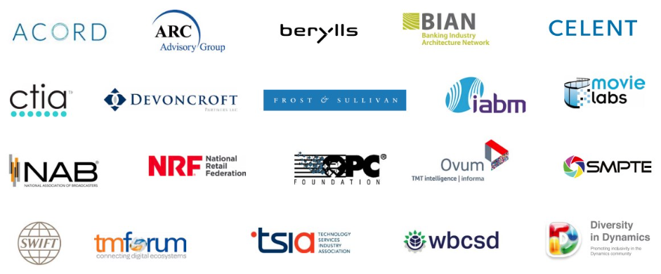

**Find out more about how to leverage *Technology Record***

Contact us about the wealth of marketing opportunities available to Microsoft partners looking to promote their brand:

**Advertising and sponsorship:** Ricky Popat - [ricky.popat@technologyrecord.com](mailto:ricky.popat@technologyrecord.com)

**Executive editor:** Andy Clayton-Smith - [andy@technologyrecord.com](mailto:andy@technologyrecord.com)

**Editorial lead:** Alice Chambers - [alice.chambers@tudor-rose.co.uk](mailto:alice.chambers@tudor-rose.co.uk)

**Digital content lead:** Amber Hickman - [amber.hickman@tudor-rose.co.uk](mailto:amber.hickman@tudor-rose.co.uk)

**Further information**

*Technology Record* is published quarterly by Tudor Rose. To find out more or to view back issues visit www.technologyrecord.com. This editorial plan is subject to the availability of those organisations and individuals listed. Alternative contributors will be found wherever possible.